Deploying Angular calculator using nodejs and npm (javascript) in nginx:

Step 1
*Launch 2 servers (1 Build server 1Deploy server)
Build server:-
Sudo apt update
Sudo apt install nodejs

Sudo apt install npm
Sudo apt install -g @angular/cli
curl -fsSL https://raw.githubusercontent.com/nvm- sh/nvm/master/install.sh | bash
nvm install 20

export NODE_OPTIONS=--openssl-legacy-provider

Ng build
Dist folder created is created

STEP 2
Deploy server
nginx Install nginx
Nginx exposed
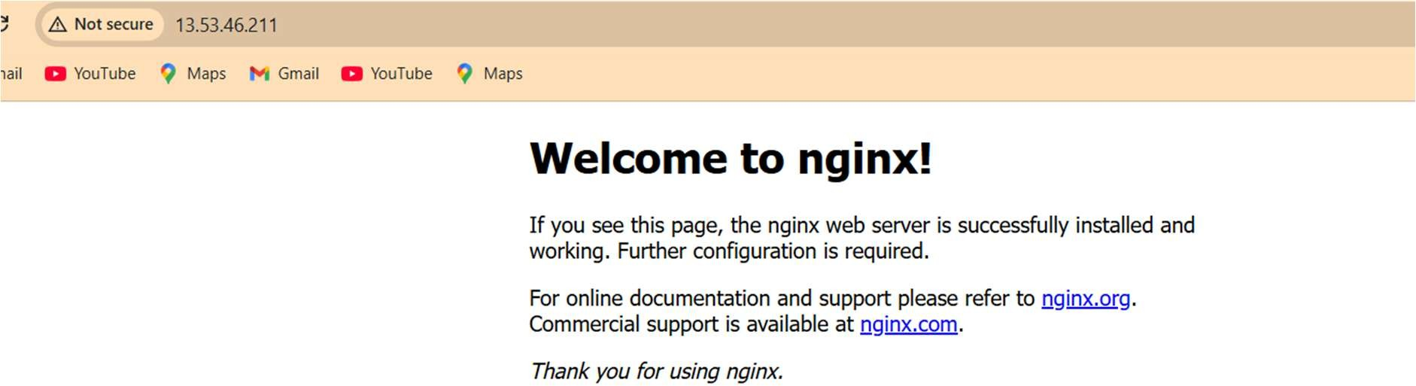

Give permissions:
sudo chown -R www-data:www-data /var/www/html sudo chmod -R 755 /var/www/html

Expose the app

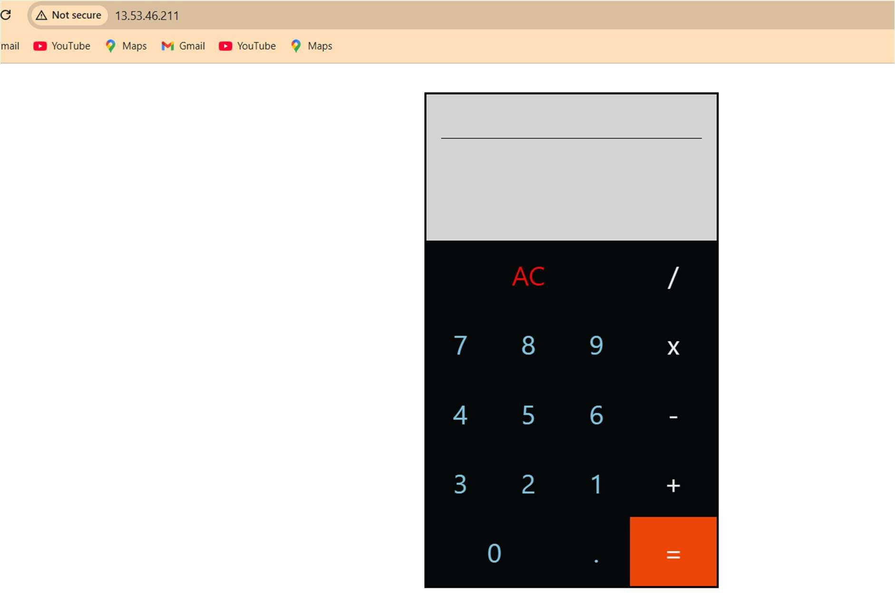

App is working